**Filipe Santo**

**Design Patterns**

1. Prototype Pattern

Location:

ganttproject/src/main/java/net/sourceforge/ganttproject/ChartComponentBase.java

Explanation:

This class lets us create copies of objects without depending on the concrete class.

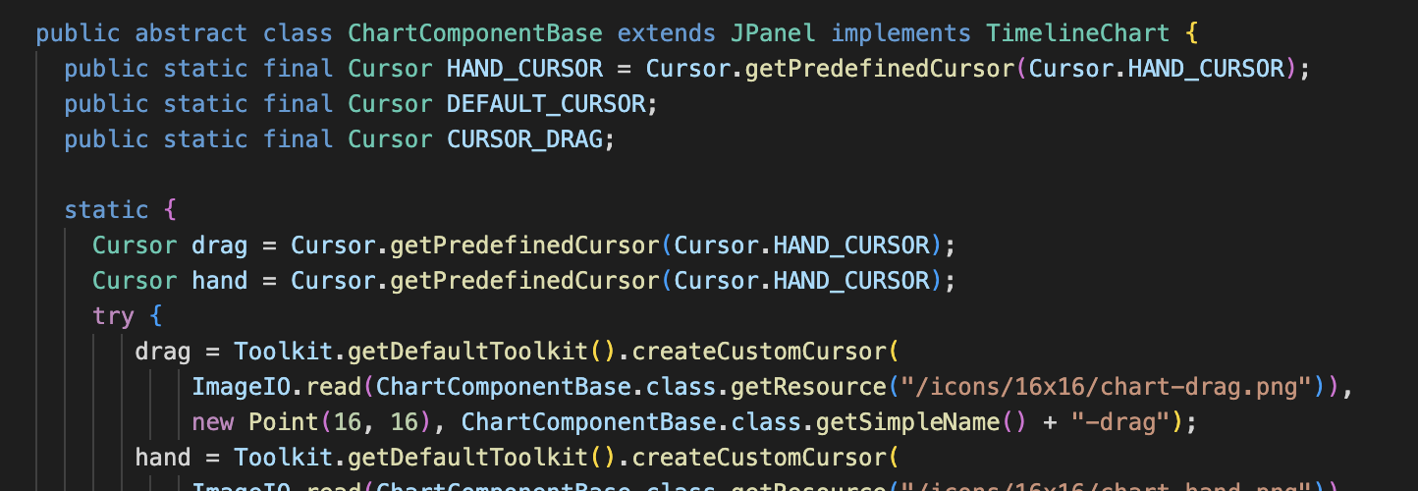

1. Singleton Pattern

Location:

ganttproject/src/main/java/net/sourceforge/ganttproject/gui/GanttLookAndFeels.java

Explanation:

This singleton class provides us global access to the info about the installed LookAndFeels.

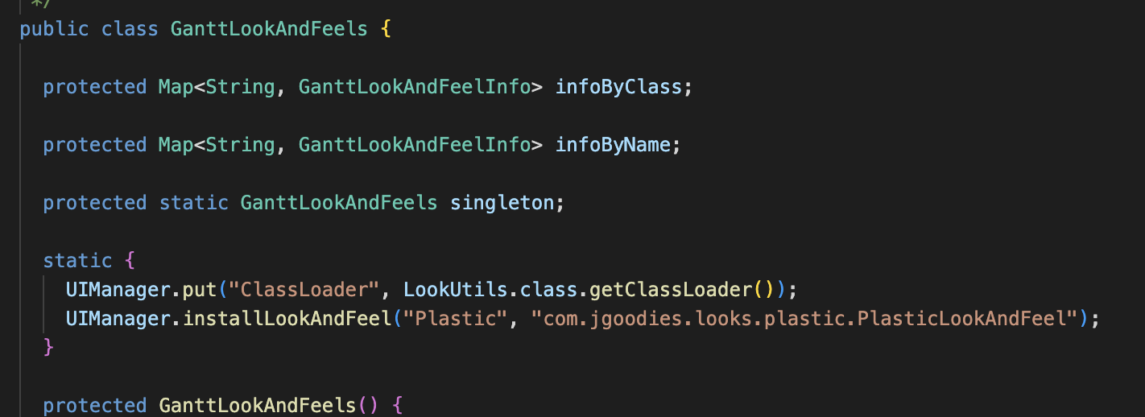

1. Proxy Pattern

Location: ganttproject/src/main/java/net/sourceforge/ganttproject/document/ReadOnlyProxyDocument.java

Explanation:  
This class has the same interface as the original service object, and when it's updated it passes from this class to the original documents object. Delegating it all the work to it.

